close all;
clc, clear;
%{
|=====ENG 180 Project 9=====|
File: ENG126_PJ1_main_Hieu_Bui.m
Author: Hieu Bui
Date: 04/09/2023
Description: Compute non-dimensional parameters for flow over
2D circular cylinder with uniform, doublet, and
vortex flows
%}
[Cl_0,Cd_0] = circularBodyFlow(0,0) % no circulation
[Cl_1,Cd_1] = circularBodyFlow(1,0) % circulation less than critical
[Cl_2,Cd_2] = circularBodyFlow(2,0) % circulation equal critical
[Cl_3,Cd_3] = circularBodyFlow(3,1) % circulation greater than critical
% gamma => gamma values for problem 2
% p3 => compute problem 3 when p3 =1
function [lift_coefficient, drag_coefficient] = circularBodyFlow(gamma,p3)
cylinder_radius = 1;
farField_velocity = 1;
% Polar grid
r_range = linspace(cylinder_radius, 3, 5);
theta_range = linspace(0, 2*pi, 31);
[r, theta] = meshgrid(r_range, theta_range);
x_polar = r.*cos(theta);
y_polar = r.*sin(theta);
%===========Problem 2=============%
% Compute velocity components
critical_circulation = 4*pi*farField_velocity*cylinder_radius;
radial_velocity = farField_velocity*cos(theta).*(1-((cylinder_radius.^2)./(r.^2)));
if gamma == 0 % no circulation
angular_velocity = -farField_velocity*sin(theta).*(1+((cylinder_radius.^2)./(r.^2)));
elseif gamma == 1 % circulation less than critical
angular_velocity = -farField_velocity*sin(theta).*(1+((cylinder_radius.^2)./(r.^2)))-(critical_circulation*.4)./(2*pi*r);
elseif gamma == 2 % circulation equal critical
angular_velocity = -farField_velocity*sin(theta).*(1+((cylinder_radius.^2)./(r.^2)))-critical_circulation./(2*pi*r);
elseif gamma == 3 % circulation greater than critical
angular_velocity = -farField_velocity*sin(theta).*(1+((cylinder_radius.^2)./(r.^2)))-(critical_circulation*1.4)./(2*pi*r);
end
x_velocity = -sin(theta).*angular_velocity + cos(theta).*radial_velocity;
y_velocity = cos(theta).*angular_velocity + sin(theta).*radial_velocity;
total_velocity = sqrt(y_velocity.^2+x_velocity.^2);
% aerodynamic coefficients
pressure_coefficient = 1 - ((radial_velocity.^2+angular_velocity.^2)./farField_velocity);
surface_pressure_coefficient = pressure_coefficient(:,1)';
lift_coefficient = -.5.*trapz(theta_range, (surface_pressure_coefficient.*sin(theta_range)));
drag_coefficient = -.5.*trapz(theta_range, (surface_pressure_coefficient.*cos(theta_range)));
%===========Problem 3=============%
if p3==1
circulation_vector = linspace(0,critical_circulation*1.4,20); % circulation gamma as a vector
% declaring vectors
Cl = zeros(1,20);
Cl_analytical = zeros(1,20);
Cd = zeros(1,20);
lift = zeros(1,20);
drag = zeros(1,20);
theta_stagnation_analytical = zeros(1,20);
theta_stagnation_numerical = zeros(1,20);
% compute aerodynamics parameters for all circulation values
for i = 1:length(circulation_vector)
tangential_velocity = -farField_velocity*sin(theta).*(1+((cylinder_radius.^2)./(r.^2)))-circulation_vector(i)./(2*pi*r);
Cp = 1 - ((radial_velocity.^2+tangential_velocity.^2)./farField_velocity);
Cp_surf = Cp(:,1)';
lift_integration_formula = Cp_surf.*cylinder_radius.*sin(theta_range);
drag_integration_formula = Cp_surf.*cylinder_radius.*cos(theta_range);
Cl(1,i) = -.5.*trapz(theta_range, (Cp_surf.*sin(theta_range)));
Cl_analytical(1,i) = circulation_vector(i)/(cylinder_radius*farField_velocity);
Cd(1,i) = -.5.*trapz(theta_range, (Cp_surf.*cos(theta_range)));
lift(1,i) = -trapz(theta_range, lift_integration_formula);
drag(1,i) = -trapz(theta_range, drag_integration_formula);
surface_velocity = sqrt(tangential_velocity(:,1).^2+radial_velocity(:,1).^2);
[~,X] = min(surface_velocity);
theta_stagnation_numerical(1,i) = abs(wrapToPi(theta(X,1)));
theta_stagnation_analytical(1,i) = asin(circulation_vector(i)/(4*pi*farField_velocity*cylinder_radius));
end
% Plotting Cl, Cd, and stagnation angle
figure('units','normalized','outerposition',[0 0 1 1]);
subplot(3,1,1)
hold on
plot(circulation_vector,Cl_analytical);
plot(circulation_vector,Cl,'ro');
xlabel('\Gamma',Interpreter='tex')
ylabel('C_l',Interpreter='tex')
legend('Analytical Solution','Numerical Solution')
title('Circulation vs Coefficient of Lift')
subplot(3,1,2)
plot(circulation_vector,Cd);
xlabel('\Gamma',Interpreter='tex')
ylabel('C_d',Interpreter='tex')
title('Circulation vs Coefficient of Drag')
subplot(3,1,3)
hold on
plot(circulation_vector,theta_stagnation_analytical)
plot(circulation_vector,theta_stagnation_numerical)
xlabel('\Gamma',Interpreter='tex')
ylabel('\theta_{stag} (radian)',Interpreter='tex')
legend('Analytical Solution','Numerical Solution')
title('Circulation vs Stagnation Angle')
sgtitle('Problem 3: Varying Circulation')
else
end
%===========Plotting for problem 2=============%
figure('units','normalized','outerposition',[0 0 1 1]);
subplot(2,3,1)
contourf(x_polar,y_polar,radial_velocity,20);
colorbar;
title('Component of Radial Velocity Distribution');
subplot(2,3,2)
contourf(x_polar,y_polar,angular_velocity,20);
colorbar;
title('Component of Tangential Velocity Distribution');
subplot(2,3,3)
contourf(x_polar,y_polar,total_velocity,20);
colorbar;
title('Total Velocity Distribution');
subplot(2,3,4)
quiver(x_polar,y_polar,x_velocity,y_velocity);
axis equal;
title('Velocity Vector Field')
subplot(2,3,5)
hold on
contourf(x_polar,y_polar,pressure_coefficient,20);
contour(x_polar, y_polar, pressure_coefficient, [0,0],'r','LineWidth',2,'ShowText','on');
colorbar;
title('Pressure Coefficient Distribution');
subplot(2,3,6)
plot(theta_range,surface_pressure_coefficient);
title('Pressure Coefficient at Surface')
xlabel('\theta (radians)',Interpreter='tex');
ylabel('Cp');
if gamma == 0
sgtitle('Problem 2: Circulation = 0')
elseif gamma == 1
sgtitle('Problem 2: Circulation Less Than Critical')
elseif gamma == 2
sgtitle('Problem 2: Circulation Equal Critical')
else
sgtitle('Problem 2: Circulation Greater Than Critical')
end
end
Cl_0 =
1.9429e-16
Cd_0 =
1.1102e-16
Cl_1 =
5.0265
Cd_1 =
1.3878e-16
Cl_2 =
12.5664
Cd_2 =
-1.2212e-15
Warning: Imaginary parts of complex X and/or Y arguments ignored.
Cl_3 =
17.5929
Cd_3 =
-6.6613e-16
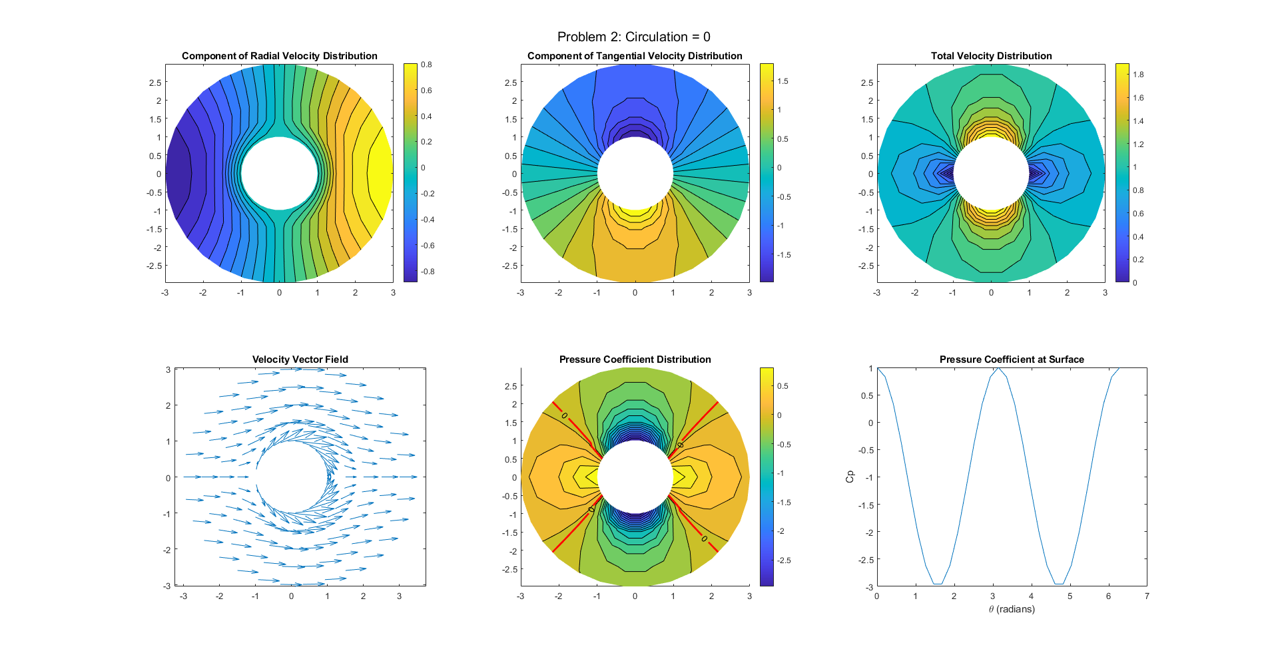
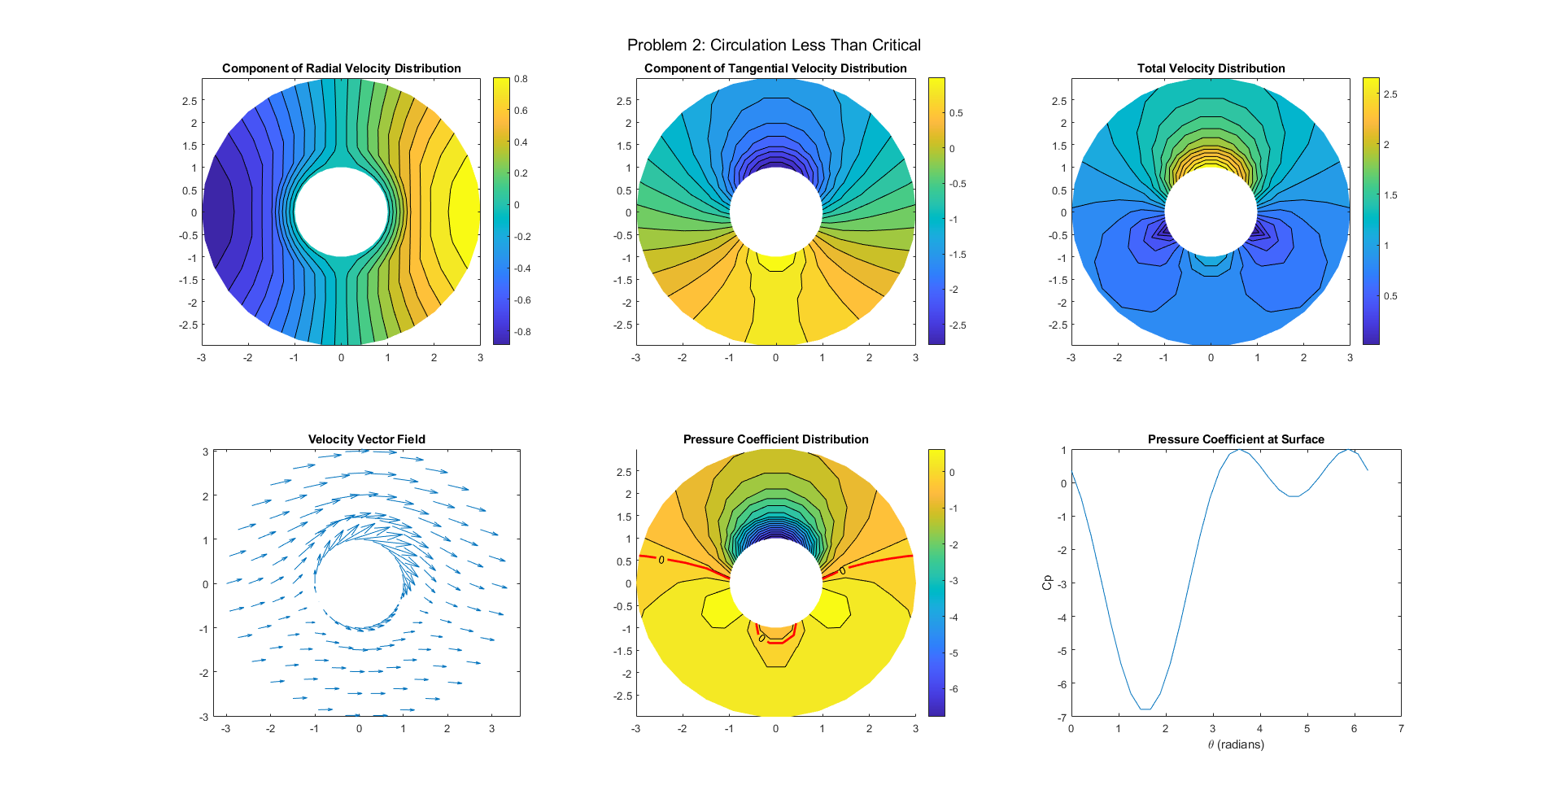
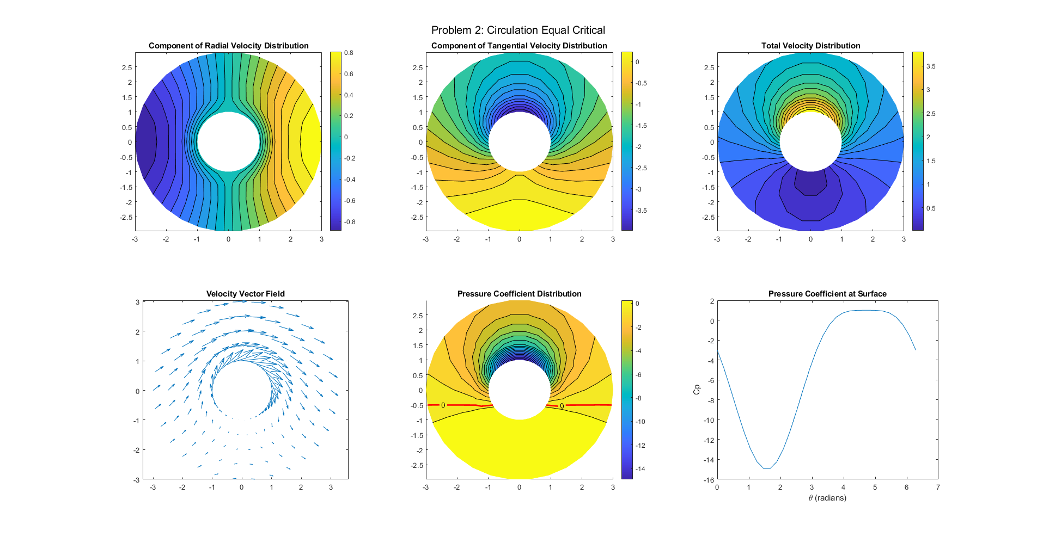
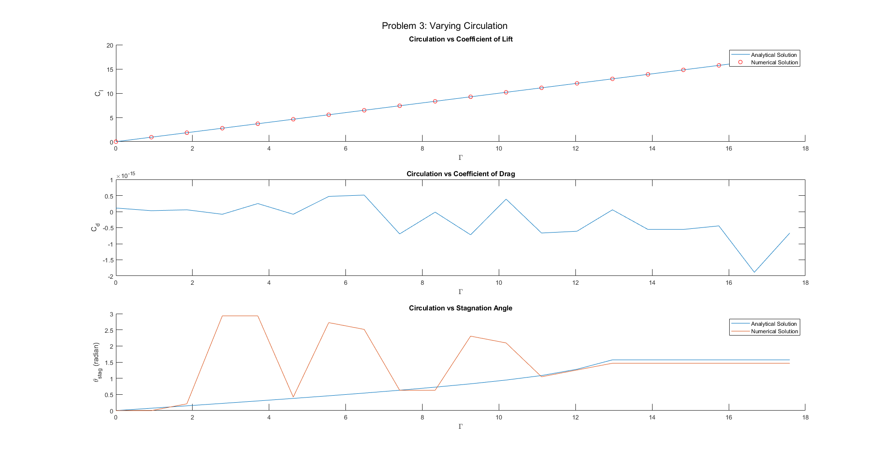
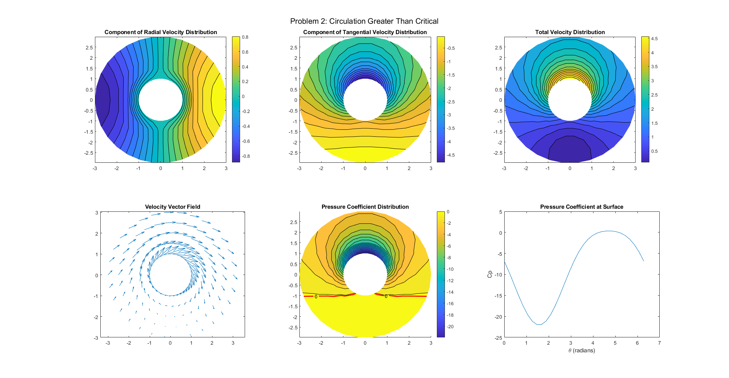
Published with MATLAB® R2021b

